EMA Crossover Signal Strategy
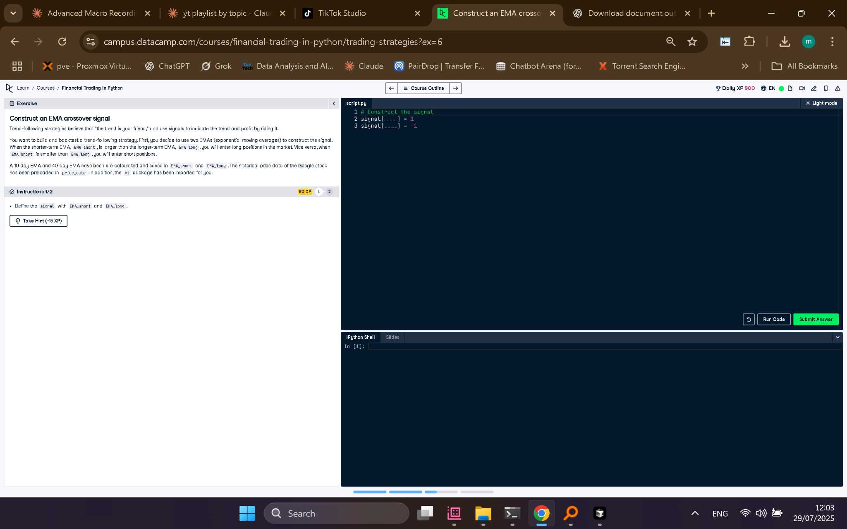

Python Code
# Construct the signal
signal[EMA_short > EMA_long] = 1
signal[EMA_short < EMA_long] = -1

Explanation (50 words)
This strategy creates a trading signal using two EMAs: short and long term. It signals 'buy' (1) when the short EMA crosses above the long EMA, and 'sell' (-1) when it crosses below.

